|  |  |
| --- | --- |
| \\VFILERDPI\DPI-Home\OBRIENR2\My Documents\Downloads\PP logo.jpg |  |
| **COUNCIL ASSESSMENT REPORT**  HUNTER AND CENTRAL COAST REGIONAL PLANNING PANEL | |

|  |  |
| --- | --- |
| **PANEL REFERENCE and DA NUMBER** | PPSHCC-35 - DA/2238/2017 |
| **PROPOSAL** | Residential subdivision (2 into 209 lots), two super lots (private parks), one drainage reserve, two public reserves and heritage walkway |
| **ADDRESS** | Lots 1, 2, 3 and 4 DP 1180181  1A, 2B, 41 and 69A Flowers Drive, Catherine Hill Bay |
| **APPLICANT** | Monteath and Powys Pty Ltd |
| **OWNER** | Wallalong Land Development Pty Ltd |
| **DA LODGEMENT DATE** | 24 November 2017 |
| **APPLICATION TYPE** | Development application |
| **REGIONALLY SIGNIFICANT CRITERIA** | Clause 20 of SRD SEPP and Schedule 4A of EP&A Act – General development over $20 million (cl.3) and coastal subdivision (cl.9) |
| **CIV** | $46,740,000 |
| **CLAUSE 4.6 REQUESTS** | Nil |
| **KEY SEPP/LEP** | Concept Plan MP10_0089 – Middle Camp Residential Development (Southern Estates) |
| **TOTAL & UNIQUE SUBMISSIONS KEY ISSUES IN SUBMISSIONS** | Nine submissions have been received in total.  Four submissions in objection were received during the first notification period, and a further four submissions in objection were received during the latest (fourth) notification period. One submission was also tabled at the October 2021 RPP briefing.  No submissions were received during the second and third notification.  The key issues raised in the submissions are:   * increased traffic in Catherine Hill Bay village * traffic safety at intersection of Flowers Drive and Pacific Highway * stormwater management * ecology impacts due to clearing * utility provision * European and Aboriginal Heritage * confirmation of the Statement of Commitments * visual impacts * rights of existing tenants * geotechnical and contamination * beach access via Town Commons |
| **ATTACHMENTS SUBMITTED FOR CONSIDERATION** | * Attachment A: Draft conditions of consent * Attachment B: Concept Approval compliance table * Attachment C: Urban Design Guidelines compliance table |
| **SPECIAL INFRASTRUCTURE CONTRIBUTIONS (S7.24)** | Condition 1.14 of the Concept Approval requires state infrastructure contributions. Documentation confirming satisfactory arrangements have been arranged has been submitted on 1 April 2020. |
| **RECOMMENDATION** | Approval |
| **DRAFT CONDITIONS TO APPLICANT** | Yes |
| **SCHEDULED MEETING DATE** | 19 October 2022 |
| **PREPARED BY** | David Pavitt, Section Manager – Development Engineering  Alex Bennett, Senior Development Engineer |
| **DATE OF REPORT** | 12 October 2022 |

**EXECUTIVE SUMMARY**

The development application (DA/2238/2017), lodged 24 November 2017, seeks consent for a residential subdivision (2 into 209 lots), two super lots (private parks), one drainage reserve, two public reserves and a heritage walkway.

The development is permitted under Concept Plan MP10_0089 which was approved in 2012 for residential development of up to 222 lots, dedication of conservation land comprising approximately 526 hectares, and associated infrastructure.

The site is known as 1A, 2B, 41 and 69A Flowers Drive, Catherine Hill Bay and comprises 42.7 hectares of land.

The environmental planning instruments relevant to the proposal include *State Environmental Planning Policy (State and Regional Development) 2011, State Environmental Planning Policy (Transport and Infrastructure) 2021, State Environmental Planning Policy (Biodiversity and Conservation) 2021, State Environmental Planning Policy (Resilience and Hazards) 2021* and *Lake Macquarie Local Environmental Plan 2014.*

The proposal is consistent with various provisions of the legislation including:

* Clause 2.122(4) traffic generating development of *State Environmental Planning Policy (Transport and Infrastructure) 2021* for subdivision of 200 or more residential lots. The application was referred to TfNSW who confirmed the proposal is satisfactory with respect to the SEPP.
* Clause 2.48 of *State Environmental Planning Policy (Transport and Infrastructure) 2021,* response to the notice from Ausgrid has been received and taken into consideration.
* *State Environmental Planning Policy (Biodiversity and Conservation) 2021* as the land is not core koala habitat.
* Clause 2.7 of *State Environmental Planning Policy (Resilience and Hazards) 202*1 is a transferred provision which does not apply to the current application due to the savings provision in the SEPP Coastal Management 2018 which has been carried over through clause 1.4 of the SEPP Resilience and Hazards 2021. The impact of the development to nearby wetlands was assessed through the Concept Approval process which is considered to be achieved appropriate outcomes for protection of nearby wetlands.
* Clause 4.6 of *State Environmental Planning Policy (Resilience and Hazards) 2021* as appropriate investigations have been undertaken and it has been demonstrated that the contaminated land can be remediated to be suitable for its intended residential use.

The application must also be consistent with the Concept Approval. The proposal has been assessed as being consistent with the Concept Approval as detailed in Appendix B.

The development is not integrated development or development requiring concurrence as the development is a transitional Part 3A Project, and instead the terms of the Concept Approval apply. In accordance with the Concept Approval, the application was referred to Department of Planning, Industry and Environment, Office of Environment and Heritage, Transport for NSW, NSW Rural Fire Service, and Subsidence Advisory NSW. All agencies who have been referred to are satisfied with the proposal.

The application was placed on public exhibition four times:

* 30 November 2017 to 14 December 2017
* 6 February 2020 to 27 February 2020
* 21 June 2021 to 13 July 2021
* 25 May 2022 to 16 June 2022

Nine submissions have been received in total. Four submissions in objection were received during the first notification period, and a further four submissions in objection were received during the latest (fourth) notification period. One submission was also tabled at the October 2021 RPP briefing. No submissions were received during the second and third notification periods. The issues raised in the submissions relate to increased traffic in Catherine Hill Bay village, traffic safety at intersection of Flowers Drive and Pacific Highway, stormwater management, ecology impacts due to clearing, utility provision, European and Aboriginal Heritage, confirmation of the Statement of Commitments, visual impacts, rights of existing tenants, geotechnical and contamination, and beach access via ‘Town Commons’. These issues are considered further in this report.

There have been several request for information letters issued over the assessment period. The application was reported to the Hunter and Central Coast Regional Planning Panel in October 2021, with the Panel resolving to defer the determination of the application to address outstanding issues. The application is now reported back to the Panel following resolution of the issues.

The application is referred to the Hunter and Central Coast Regional Planning Panel as the development is regionally significant development, as the proposal is development with a CIV over $20 million (Schedule 7(2)), and is classified as a coastal subdivision (Schedule 7(8)) in accordance with *State Environmental Planning Policy (State and Regional Development) 2011,* which was in force at the time of the DA being lodged. The development’s status as regionally significant development is unchanged under *State Environmental Planning Policy (Planning Systems) 2021.*

Multiple briefings have been held with the Panel on 3 June 2020, 9 September 2020, 14 July 2021, 13 October 2021, 1 June 2022 and 4 August 2022. Several key issues were discussed including background of concept approval, consistency of development with concept approval, statutory framework, servicing strategy and environmental impacts, and boundary conditions and potential impacts.

The key issues associated with the proposal include:

* Concept Approval consistency
* contamination
* biodiversity offsets
* bushfire protection
* visual impacts
* traffic impacts
* ecological impacts from servicing
* Workshop Building retention or demolition
* Workshop Park and Lemon Tree Park
* European heritage and heritage walkway
* stormwater management
* impacts to adjacent state conservation area.

Following a detailed assessment of the proposal, the application is recommended for approval.

1. **THE SITE AND LOCALITY**

**1.1 The locality**

The site is located within Catherine Hill Bay, which is a suburb located on the coast in the south-east of the Lake Macquarie local government area.

Access to Catherine Hill Bay is from the Pacific Highway via Flowers Drive (northern access) and Montefiore Drive (southern access). The township is not serviced by reticulated water or sewer.

The town nestles in a natural amphitheatre with ridgelines to the north, south and west, and the ocean directly to the east. The town is surrounded by the Munmorah State Conservation Area, which adjoins the Wallarah National Park to the north and Lake Macquarie State Conservation Area to the east.

Catherine Hill Bay was developed as a result of coal mining operations adjacent to the township. The town traditionally consisted of approximately 100 modest former mining cottages in two villages known as Middle Camp in the north and Catherine Hill Bay township in the south. Middle Camp contains approximately 50 former mining cottages and is accessed primarily by Flowers Drive. The Catherine Hill Bay township is similarly modest in scale but contains other amenities such as a pub and surf lifesaving club.

Recently a residential subdivision known as “Beaches Estate” has been developed by the Rose Group to the south of the town, which is approximately 90% complete and will contain over 500 dwellings and a small retail precinct. The Rose Group development and the development proposed under the current development application were both major projects assessed by the state government.

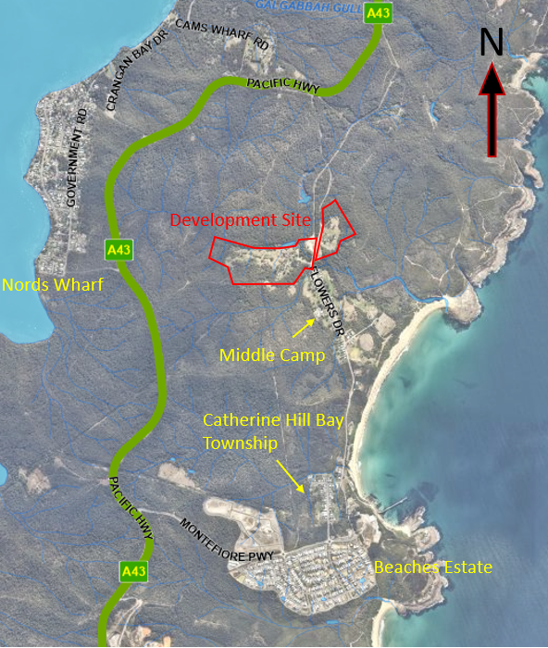

**Figure 1: Location plan**

**1.2 Site background**

The site forms part of Concept Plan MP10_0089 which was approved by the Planning Assessment Commission in 2012 for residential development of up to 222 lots over two hamlets, dedication of conservation land comprising approximately 526 hectares, and associated infrastructure.

The Concept Approval was to lapse after five years if no development application was lodged, however the Concept Approval was modified in July 2017 to obtain an extension of 12 months until July 2018. The current development application was lodged in November 2017 and as such the Concept Approval is still alive.

A development application for demolition of the Workshop Building in Hamlet B has been assessed and approved by Council. The application did not include subdivision, and therefore sat outside of, and did not benefit from the Concept Approval.

**1.3 The site**

The site is located north of the Middle Camp village. The residential portion of the site is divided into two distinct hamlets, Hamlet A and Hamlet B (refer to Figure 2).

Hamlet A has an area of 7.3 hectares and is located on the eastern side of Flowers Drive. Hamlet B has an area of 20.88 hectares and is located to the west of Flowers Drive and is bordered to the north, west and south by Munmorah State Conservation Area.

Hamlet A was the location of a former sawmill that serviced the historical coal mining operations on Hamlet B. The land is cleared and is currently used primarily for grazing and contains a dwelling and outbuildings.

Hamlet B was the location for the main historical mining operations. The land has some regrowth but is generally cleared and is currently used primarily for grazing and contains several dwellings and outbuildings, and heritage items as a result of the former mining activities on the site. There are known shallow mine workings within this land.

The site also includes a heritage walkway that extends from Hamlet B to the east over Middle Camp Gully and then to the south along the former rail corridor. This corridor includes land that the former rail corridor.

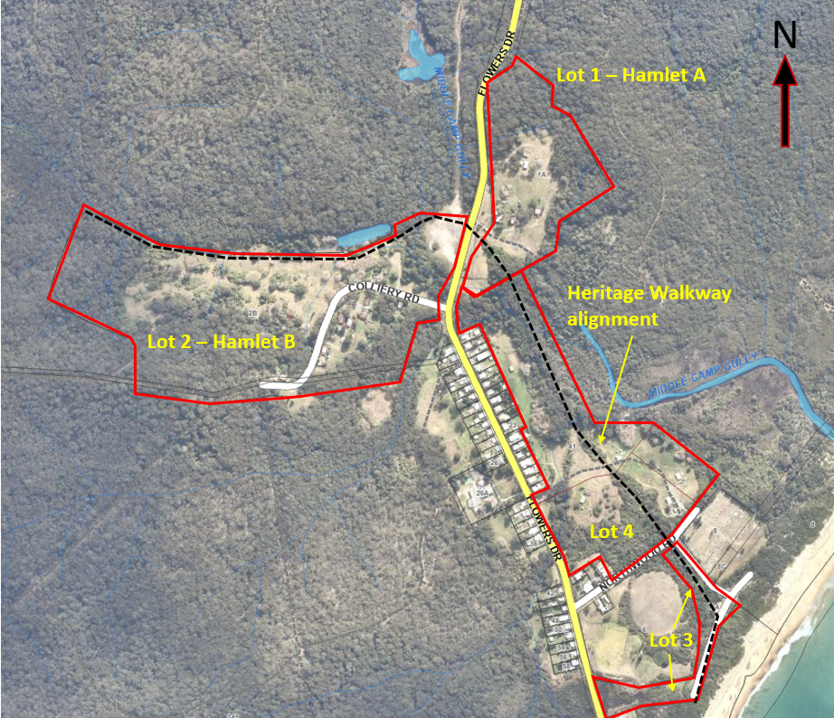

**Figure 2: Location plan of Hamlet A and B, heritage walkway alignment and other land included in application**

1. **THE PROPOSAL AND BACKGROUND** 
   1. **The proposal**

The proposal seeks consent for a residential subdivision (2 into 209 lots), two super lots (private parks), one drainage reserve, two public reserves and a heritage walkway.

Specifically the development includes:

* site preparation works including earthworks, clearing of vegetation, contamination remediation and grouting of shallow mine workings for the removal of subsidence risk in Hamlet B
* construction of roads, drainage and utility infrastructure
* creation of two super lots (Workshop and Lemon Tree Park)
* creation of 209 residential lots

Hamlet A will include 50 residential lots, and Hamlet B will include 159 residential lots (refer to Figures 3 and Figure 4).

* landscaping to streets, drainage reserves and public reserves
* dedication of drainage and public reserve areas to Lake Macquarie City Council
* heritage interpretation along the alignment of the heritage walkway and at Workshop and Lemon Tree Parks
* upgrading of intersection of Flowers Drive and Pacific Highway in accordance with the Concept Approval
* construction of a heritage walkway from Hamlet B to the east over Middle Camp Creek and then to the south along the former rail corridor
* provision of contributions and infrastructure in accordance with the approved Staging Plan by the Department of Planning, Industry and Environment (DPIE).

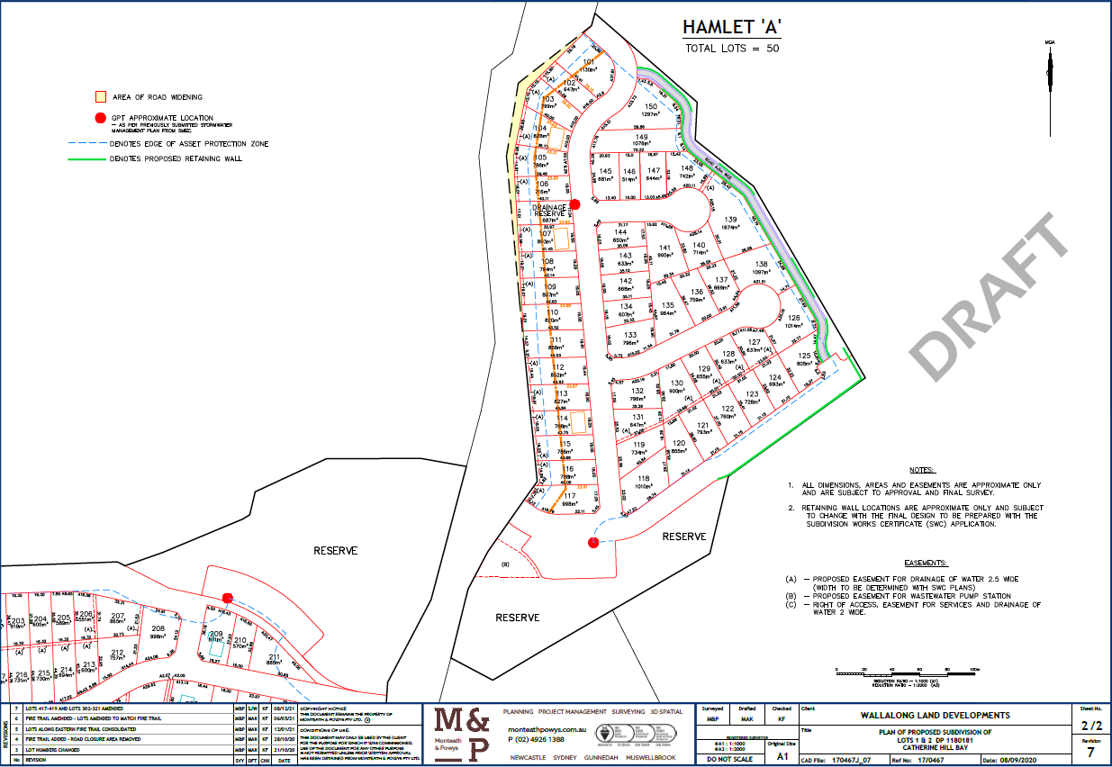

**Figure 3: Hamlet A lot layout**

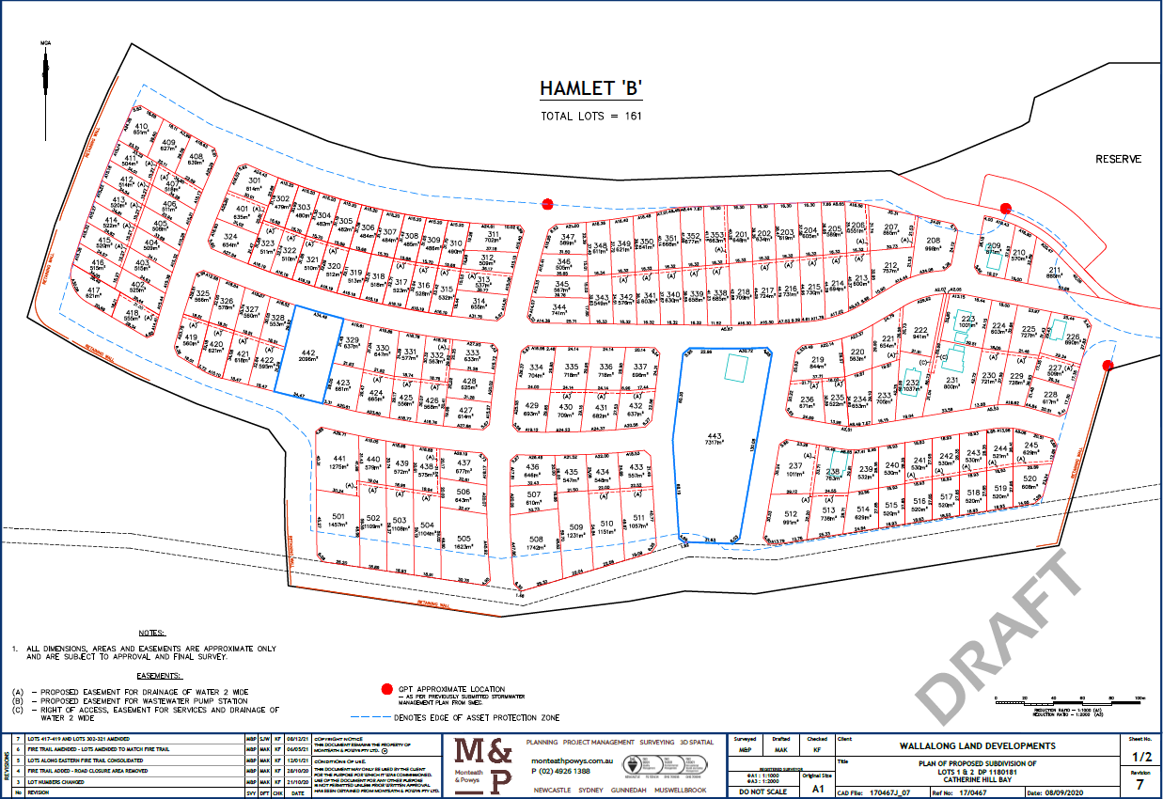

**Figure 4: Hamlet B lot layout**

* 1. **Background of application**

The application was lodged on 24 November 2017. A timetable and key milestones of the application since lodgement is outlined below including the Panel’s involvement with the application.

**Table 1: Timetable and milestones of DA**

|  |  |
| --- | --- |
| **Date** | **Event** |
| **Exhibition** | |
| 30 November – 18 December 2017  6 February – 27 February 2020  21 June – 13 July 2021  26 May – 16 June 2022 | Exhibition of the application |
| **Transport for NSW** | |
| 30 November 2017 | Referred to TfNSW |
| 5 October 2021 | TfNSW response received in accordance with SEPP Infrastructure |
| 8 February 2022 | Notification TfNSW are not undertaking intersection works |
| 26 May 2022 | Additional referral to TfNSW |
| 16 June 2022 | TfNSW response received in accordance with SEPP Transport and Infrastructure 2021 |
| 24 August 2022 | Additional response from TfNSW received confirming support for application |
| **NSW RFS** | |
| 19 December 2017 | Referred to NSW RFS |
| 17 November 2020 | NSW RFS objection to development |
| 3 June 2021 | NSW RFS approval received in accordance with condition 1.40 and 1.41 of Concept Approval |
| 25 May 2022 | Re-referred to NSW RFS |
| 9 August 2022 | NSW RFS approval re-issued in accordance with condition 1.40 and 1.41 of Concept Approval |
| **NSW Heritage Council** | |
| 26 November 2020 | Advice received – no comment required |
| **DPIE** | |
| 2 April 2020 | Satisfactory Arrangement Certificate from DPIE for state infrastructure contributions |
| **DPIE** | |
| 28 January 2021 | Staging plan approved by DPIE |
| 28 April 2022 | Correspondence received from Biodiversity and Conservation Division of DPE (Condition 1.16f of Concept Approval) |
| 24 August 2022 | Additional correspondence from Biodiversity and Conservation Division of DPIE confirming Condition 1.16f of Concept Approval has been satisfactorily met subject to conditions |
| **Ausgrid** | |
| 5 October 2021 | Referred to Ausgrid |
| 12 October 2021 | Ausgrid response received |
| **Subsidence Advisory NSW** | |
| 27 February 2020 | Conditions of approval issued |
| **HCC RPP Briefings** | |
| 3 June 2020 | Panel briefing |
| 9 September 2020 | Site inspection |
| 14 July 2021 | Panel briefing |
| 13 October 2021 | Determination meeting (matter deferred) |
| 1 June 2022 | Panel briefing |
| 4 August 2022 | Panel briefing |
| **Date** | **Event** |
| **Request for information and document submission summary** | |
| 15 June 2018 | Initial request for information |
| 20 December 2019 | Response received to June 2018 RFI |
| 20 Feb 2020 | Submission of further updated information by applicant |
| 8 April 2020 | Second RFI by Council |
| 15 July 2020 | Response received to second RFI and submission of updated information |
| 10 November 2020 | Submission of updated information by applicant in response to RPP site inspection |
| 24 March 2021 | Submission of further updated information by applicant |
| 14 May 2021 | Submission of further updated information by applicant |
| 21 July 2021 | Third RFI by Council |
| 17 August 2021 | Response received to third RFI of Council and submission of updated information |
| **Date** | **Event** |
| 9 November 2021 | Fourth RFI by Council |
| 10 November 2021 | Correspondence received from applicant committing to addressing outstanding matters |
| 16 May 2022 | Submission of updated application documentation by applicant |
| 6 October 2022 | Additional submission of updated application documentation by applicant |

1. **STATUTORY CONSIDERATIONS**

When determining a development application, the consent authority must take into consideration the matters outlined in Section 4.15(1) of the *Environmental Planning and Assessment Act 1979* (EP&A Act). These matters as are of relevance to the development application include the following:

1. *the provisions of any environmental planning instrument, proposed instrument, development control plan, planning agreement and the regulations*
2. *the likely impacts of that development, including environmental impacts on both the natural and built environments, and social and economic impacts in the locality,*
3. *the suitability of the site for the development,*
4. *any submissions made in accordance with this Act or the regulations,*
5. *the public interest.*

These matters are further considered below and throughout this report.

It is noted the development is classified as a transitional Part 3A project in accordance clause 2(1)(b) of Schedule 2 of the *Environmental Planning and Assessment (Savings, Transitional and Other Provisions) Regulation 2017* (the transitional regulations). As such, Part 3A of the Act, as in force immediately before the repeal of that part, continues to apply to the project in accordance with clause 3(1) of the transitional regulations.

Therefore, in accordance with clause 75P(2)(b) of the repealed part of the Act that still applies to the project, the development is not classified as integrated development. However, as required by conditions of the Concept Approval, the application was referred to Department of Planning, Industry and Environment (DPIE), Office of Environment and Heritage (OEH), Transport for NSW (TfNSW), NSW Rural Fire Service (RFS) and Subsidence Advisory NSW (SA NSW).

* 1. **Section 4.15(1)(a)(i) - Provisions of Environmental Planning Instruments**

In accordance with clause 3B (2)(f) of the Translational regulations, the provisions of any environmental planning instrument do not have effect to the extent to which they are inconsistent with the terms of the Concept Approval. Assessment of the relevant EPIs is considered below.

The following EPIs are relevant to this application:

* *State Environmental Planning Policy (State and Regional Development) 2011*
* *State Environmental Planning Policy (Transport and Infrastructure) 2021*
* *State Environmental Planning Policy (Biodiversity and Conservation) 2021*
* *State Environmental Planning Policy (Resilience and Hazards) 2021*
* *Lake Macquarie Local Environmental Plan 2014*

A summary of the key matters for consideration arising from the relevant SEPPs are outlined in **Table 2** and considered in more detail below.

The majority of the SEPPs that apply to the development are consolidated SEPPs which replaced previous SEPPs that applied. The consolidated SEPPs commenced on 1 March 2022. Previous provisions from the repealed SEPPs have been transferred to the consolidated SEPPs, and under section 1.4 of each SEPP it is identified that section 30A of the *Interpretation Act 1987* is taken to apply to provisions transferred.

**Table 2: Summary of applicable State Environmental Planning Policies**

|  |  |  |
| --- | --- | --- |
| **EPI** | **Matters for consideration** | **Comply** |

|  |  |  |
| --- | --- | --- |
| SEPP State and Regional Development | * Clause 20 declares the proposal as regionally significant development pursuant to section 4.5(b) of the EP&A Act, as the development is specified in Schedule 7 (clause 2 and 8). | Y |
| SEPP Transport and Infrastructure | * Clause 2.48 – a response to the notice sent to Ausgrid has been received which identifies their requirements for the development. * Clause 2.122 - traffic-generating development – subdivision of 200 of more residential lots   Referral sent to Transport for NSW and response provided confirming the proposal is satisfactory with respect to these provisions. | Y  Y |
| SEPP Biodiversity and Conservation | * Part 3.2 (clauses 3.5 – 3.9) of the SEPP applies as the land is greater than one hectare and an assessment must be made as to whether the land is potential or core koala habitat.   Land was determined to not be core Koala habitat. | Y |
| SEPP Resilience and Hazards | Chapter 2 – Coastal Wetlands   * The impact of the development to nearby wetlands was assessed through the Concept Approval process. A number of conditions of the Concept Approval relate to the protection of the wetland.   Clause 2.7(4) is considered to be achieved through compliance with the Concept Approval. | Y |
| Chapter 4 Remediation of land   * Clause 4.6 – a Remediation Action Plan and review by a NSW EPA accredited Site Auditor has been submitted, which confirms the land can be made suitable for the proposed residential use with the proposed remediation strategies. | Y |

**State Environmental Planning Policy (State and Regional Development) 2011**

The proposal is identified as regionally significant development under clause 20 pursuant to section 4.5(b) of the *EP&A Act* as the development is specified in Schedule 7 as general development with a CIV over $20 million (cl. 2) and regionally significant development and Schedule 4A of the *EP&A Act* as the development has a CIV over $20 million (cl.3), and is a coastal subdivision (cl.8).

The development’s status as regionally significant development is unchanged under *State Environmental Planning Policy (Planning Systems) 2021*.

The Hunter and Central Coast Regional Planning Panel will be the consent authority for the application.

**State Environmental Planning Policy (Transport and Infrastructure) 2021**

**Traffic Generating Development**

The development is traffic generating development under clause 2.122 and Schedule 3 of the SEPP as the application proposes more than 200 residential lots. As traffic generating development, the consent authority is required to give written notice to TfNSW and take into consideration any response.

The application was referred to TfNSW who confirmed the proposal is satisfactory with respect to the SEPP, and acknowledged upgrading of the intersection of Flowers Drive and the Pacific Highway will address potential traffic impacts arising from the development.

The SEPP also requires the consent authority to consider the accessibility of the site, including the efficiency of movement of people, and any potential traffic safety, road congestion or parking implications of the development. Council’s Senior Development Engineer and Traffic Engineer have assessed the proposal and confirmed the development will provide suitable internal roads and safe intersections to Flowers Drive. Parking will be available within carriageways and on the lots with future housing. Council’s Traffic Engineer has recommended an additional speed hump is installed adjacent to Hamlet A to further supplement the existing traffic calming measures through Middle Camp. Council is satisfied the proposal achieves these provisions of the SEPP.

**Development likely to affect electricity transmission or distribution network**

The development requires the consent authority to give written notice to the electricity supply authority (Ausgrid) before determining the application under clause 2.48 of the SEPP, as the development is within and adjacent to an easement for electricity purposes.

A response has been received from Ausgrid which identifies their requirements for the development, and the particular staging of when these requirements are to be met. No requirement from Ausgrid is required prior to the issue of the DA consent. Council recommends Ausgrid’s requirements are included as conditions of consent.

**State Environmental Planning Policy (Biodiversity and Conservation) 2021**

Koala habitat protection 2020

Part 3.2 (clauses 3.5 – 3.9) of the SEPP applies as land is greater than one hectare and an assessment must be made as to whether the land is potential or core koala habitat.

The biodiversity assessment submitted with the application has undertaken an assessment of koala habitat potential at the site and determined the site to be potential Koala habitat but not core Koala habitat.

**State Environmental Planning Policy (Resilience and Hazards) 2021**

**Coastal Wetlands**

At the time the development application was lodged in December 2017, SEPP 71– Coastal Protection and SEPP 14 – Coastal Wetlands were in force. It was determined that only SEPP 71 applied to the development site as the site was located within the coastal zone, and the nearest coastal wetland mapped under SEPP 14 was 1.6km to the south. The development was assessed by Council as achieving appropriate outcomes consistent with SEPP 71.

The SEPP Coastal Management 2018 was introduced on 3 April 2018, and repealed SEPP 14 and SEPP 71. The mapping of coastal wetlands was updated with the Coastal Management SEPP, and the wetland identified within the development site has been mapped as a coastal wetland. The development site is now identified as containing Coastal Wetland, Coastal Environmental Area, and Coastal Use Area. In accordance with clause 10(2), the development would be declared to be designated development, however the transitional provisions specified under section 21(3) mean the former planning provisions apply (SEPP 14 and SEPP 71) instead of the provisions of the Coastal Management SEPP.

The SEPP (Resilience and Hazards) 2021 commenced on 1 March 2022, and repealed the Coastal Management SEPP. The provisions under section 10 of the Coastal Management SEPP were transferred to section 2.7 of SEPP (Resilience and Hazards) 2021. Section 1.4 of SEPP (Resilience and Hazards) 2021 states that section 30A of the *Interpretation Act 1987* is taken to apply to the transferred provisions of the policy, which provides “the transfer of a provision does not affect the operation or meaning of the provision”. This can be taken to mean that as section 2.7 of SEPP (Resilience and Hazards) 2021 is a transferred provision which did not apply to the proposal under the Coastal Management SEPP 2018, it continues to not apply.

Clause 2.7(4) of SEPP (Resilience and Hazards) 2021 requires the consent authority to not grant consent for the development unless they are satisfied that sufficient measures will be taken to protect the biophysical, hydrological and ecological integrity of the coastal wetland. Throughout the Concept Approval process the impacts of the development on the wetland were considered, despite not being identified as coastal wetland under SEPP 14 at the time. Conditions 1.17, 1.18, 1.19, 1.24, 1.25 and 1.47 of the Concept Approval are included to ensure the biophysical, hydrological and ecological integrity of the wetland is protected from the residential development. Council’s view is the objectives of SEPP (Resilience and Hazards) 2021 are met through compliance with Concept Approval. The proposal has been assessed as being consistent with the Concept Approval. Refer to Appendix B for detailed consideration of this matter.

**Remediation of land**

Clause 4.6 of the SEPP requires the consent authority to consider whether the land is contaminated, and if the land is contaminated, it is satisfied the land is suitable in its contaminated state (or will be suitable, after remediation) for the purpose for which the development is proposed to be carried out.

The site was identified as being contaminated as part of the Concept Approval process, owing to historic mining activities and current residential use. The following contamination assessments have been carried out on the site:

* A Preliminary Contamination Assessment by Douglas Partners (2010)
* A Stage One Preliminary Site Investigation by Environmental Safety Professionals (2016)
* A Detailed Site Investigation by Douglas Partners (2019)
* A Supplementary Contamination Assessment (SCA) by Qualtest (2022)

The following contamination that requires remediation has been identified on the site:

* contaminated soils (above human health criteria) – this includes asbestos containing materials (ACM), asbestos fibres, metals, polycyclic aromatic hydrocarbons (PAHs) and total recoverable hydrocarbon (TRH) concentrations
* contaminated soils (above ecological criteria) – this includes metals and TRH
* coal and/or coal chitter – posing a combustion risk to future development.

A Remediation Action Plan (RAP) informed by the previous contamination assessments has been submitted with the application. The RAP identifies data gaps which require further assessment to conclusively determine whether the proposed measures are appropriate to make the land suitable for residential use. The data gaps requiring further assessment relate to:

* groundwater and surface water quality (to determine baseline levels prior to commencing and at the completion of site works)
* if hazardous gases are present (mainly methane) within mine voids/shafts on the site, and at what concentrations (to determine baseline levels prior to commencement and at the completion of grouting works)
* potential acid drainage from the coal and coal chitter to have impacted groundwater (to determine baseline levels prior to commencing and at the completion of site works)
* areas of potential filling in the eastern part of Hamlet B and south-eastern part of Hamlet A (to be carried out post vegetation clearing and when accessible),
* assessment of residential areas still occupied on the site (prior to construction when access becomes available to minimise disruption to residents).

A NSW EPA accredited Site Auditor has reviewed the RAP and advised that provided the additional assessments and remediation strategies are completed prior to earthworks/construction, the site can be rendered suitable for residential development in accordance with the SEPP.

Given the advice from the Auditor, Council’s view is the site can be remediated to be made suitable for residential land use, with the additional assessments identified by the RAP conditioned to be undertaken prior to the commencement of earthworks and the RAP revised if required. Council recommends an Auditor’s Validation Statement confirming the suitability of the site for residential land use prior to any Subdivision Certificate is included as a condition of consent.

**Lake Macquarie Local Environmental Plan 2014**

**Zoning and permissibility (Part 2)**

Clause 2.6 enables subdivision.

The site is located within the R2 Low density residential and C2 Environmental Conservation zones pursuant to Clause 2.2 of the LEP.

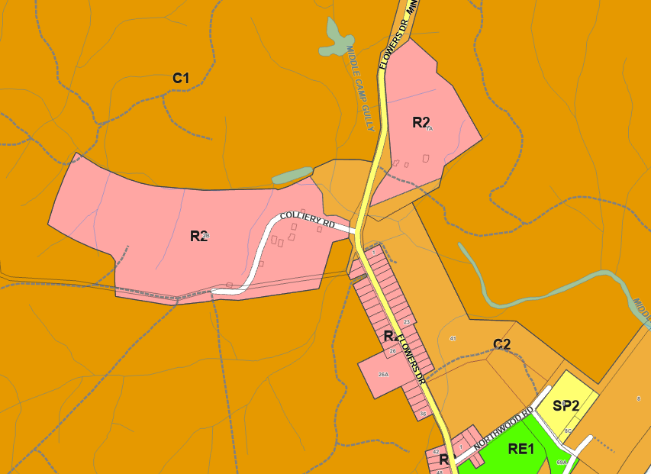

**Figure 5: Zoning extract**

**4.1 Minimum subdivision lot size**

The minimum lot size in the R2 zone is 450m2. The proposed development complies with the minimum lot size in the R2 zone.

The minimum lot size of the C2 zone is 100ha. The proposed lot within the C2 zone does not comply with the minimum lot size however is to be dedicated as public reserve as per the Concept Approval and is considered acceptable.

**4.1C Exceptions for subdivisions involving battle-axe lots or corner lots in certain zones**

Despite clause 4.1, the minimum lot size for corner lots in the R2 zone is 500m2. The proposed corner lots comply with the minimum lot size.

No battle-axe lots are proposed.

**5.10 Heritage conservation**

Development consent is required for all proposed works, as the site includes listed heritage items related to the former mining operations including:

* The application proposes to retain the heritage items except for the archaeological elements of Pit E.
* The former railway will be disturbed for the heritage walkway.
* Cottage CH-31 is proposed to be relocated on top of proposed fill in the same location so that it is no longer within the flood extent.

Development on archaeological sites requires the consent authority to notify the NSW Heritage Office. Council notified the Heritage Office, and they confirmed the items were not listed on the State Heritage Register and therefore no further comment was required from them. For further consideration of this matter, refer to the Key Issues section of this report.

**6.1 Arrangements for designated State public infrastructure**

Development consent must not be granted for the subdivision of land in an urban release area if the subdivision would create a lot smaller than the minimum lot size permitted on the land immediately before the land became part of an urban release area, unless the Secretary has certified that satisfactory arrangements have been made to contribute to the provision of designated Sate public infrastructure.

The Secretary’s certificate confirming satisfactory arrangements for State public infrastructure has been provided.

**6.2 Public utility infrastructure**

Development consent in an urban release area cannot be issued unless the consent authority is satisfied suitable arrangements for public utility infrastructure (water, sewer and electricity).

A water and sewer strategy has been provided and approved by the Hunter Water Corporation (HWC). Electricity supply is available to the development site.

**6.3 Development control plan**

Development consent must not be issued for development on land in an urban release area unless a development control plan has been prepared for the land.

Under clause 3B of the transitional regulations, the provisions of a DCP do not have effect to the development to the extent they are inconsistent with the terms of approval of the Concept Plan approval. Therefore, the concept plan approval negates the requirements for a DCP.

Irrespective, the development is subject to a set of urban design guidelines (UDG) which establish assessment controls similar to a DCP. Refer to Appendix C for detailed assessment.

**7.1 Acid sulfate soils**

The site is located in mapped acid sulfate soil class 3, 4 and 5 lands. Development consent must not be granted for specified works unless an acid sulfate soil management plan has been prepared in accordance with the Acid Sulfate Soil Manual and has been provided to the consent authority.

A suitable acid sulfate soil management plan for the proposed works has been provided.

**7.2 Earthworks**

Development consent is required for earthworks.

Both hamlets are to be regraded to adjust the landform to facilitate remediation, mine working grouting and road and drainage construction. The earthworks extents are shown in the bulk earthworks plans contained within the concept civil design plans (refer to Figure 6 and Figure 7).

Both hamlets include retaining walls (both cut and fill) to portions of the perimeters of the site where they interface with the conservation lands. At the western and eastern extents of Hamlet B, walls extend to up to 2.4 metres (cut) and 3.5 metres (fill) in height. The south eastern corner of Hamlet A has cut and fill walls at approximately 2 metres high. The remainder of the walls are less than 1.5 metres in height. All walls are offset at least 3 metres from the boundary of the site.

Within the hamlets, only Hamlet A includes internal retaining /terracing to some of the lots.

The proposed cut and fill is balanced with no fill material expected to be required to imported or exported.

The proposed earthworks are considered to be acceptable as it does not pose any adverse stormwater or environmental outcomes, supports the use of the land as anticipated by the Concept Approval, and has minimised impact on adjoining lands through design and visual amenity.

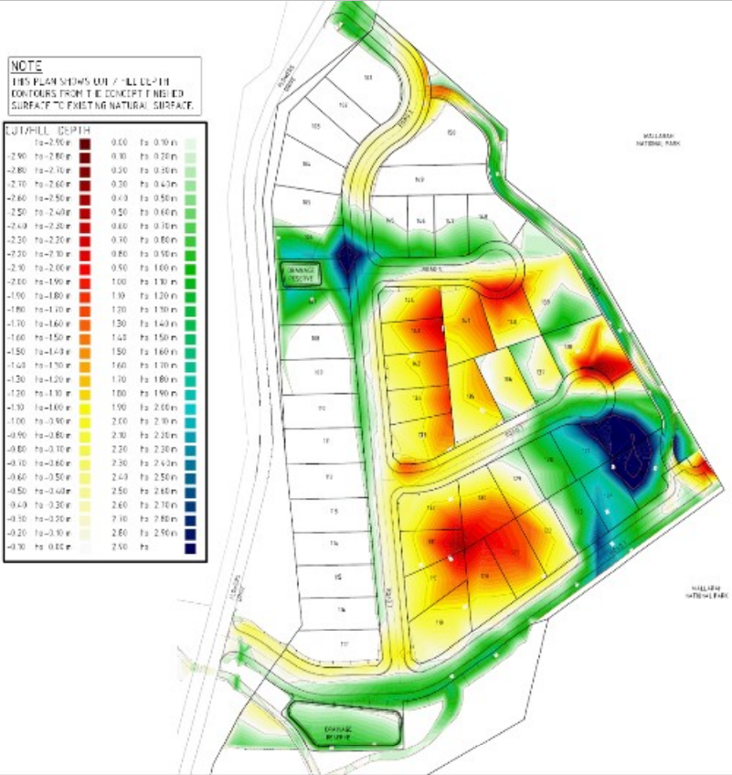

**Figure 6 Hamlet A bulk earthworks**

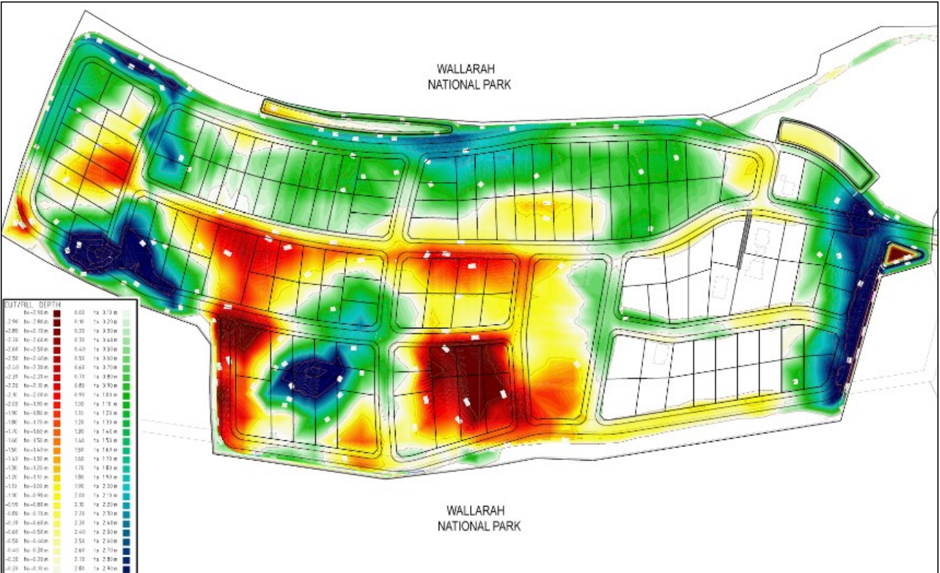

**Figure 7 Hamlet B bulk earthworks**

**7.7 Development on sensitive Aboriginal landscape areas**

For development located on land identified as sensitive Aboriginal landscape area, the consent authority may require an Aboriginal Heritage Impact Statement.

The site is identified as being within a sensitive Aboriginal landscape area. In accordance with condition 1.35 of the Concept Approval an Aboriginal Cultural Heritage Management Plan (ACHMP) has been submitted with the application. The ACHMP was prepared in consultation with Aboriginal stakeholders. Council’s Heritage Planner has confirmed the document is satisfactory and there are no Aboriginal Heritage sites or known items within the site. As such, the objective of this clause has been met and no further Aboriginal Heritage Impact Statement is considered to be required.

* 1. **Essential services**

The consent authority must not grant development consent unless they are satisfied that essential services will be available when required.

A water and sewer strategy has been submitted with the application, which proposes to extend the existing water and sewer mains in Nords Wharf to the development site via Flowers Drive. Hunter Water Corporation (HWC) have reviewed the strategy and have provided Council with their approval.

Electricity supply is available to the site. Council have notified Ausgrid in accordance with Transport and Infrastructure SEPP. Ausgrid have responded to Council, confirming their requirements for the development, which will be included as conditions of consent.

Council has assessed the application and are satisfied the development will have suitable stormwater drainage and vehicular access.

* 1. **Section 4.15 (1)(a)(ii) - Provisions of any proposed instruments**

**Draft amendment RZ/2/2021 to Lake Macquarie Local Environmental Plan (LMLEP) 2014**

The amendment has now been exhibited and adopted. The proposal seeks to change the planning controls (building height, minimum lot size, and certain development permissibility) under the LMLEP within the Catherine Hill Bay Cultural Precinct to ensure development is consistent with the heritage character. The proposal is also to implement a new DCP for the area.

The Middle Camp lands have not been included in the final version or the planning proposal, as Council resolved to rely upon the Concept Approval and associated urban design guidelines for development in this location.

No other draft EPIs relate to the site that haven’t already been addressed in this report.

* 1. **Section 4.15(1)(a)(iii) - Provisions of any Development Control Plan**

Ordinarily, the *Lake Macquarie Development Control Plan 2014 (LM DCP 2014)* would apply, however does not as the site and application are benefited by the Concept Approval.

Condition 1.11 of the Concept Approval requires adoption of revised UDGs prior to the first application for subdivision. These revised guidelines were approved by Planning and Infrastructure in 2013 and are to be used to consider the merits of the proposed development. An assessment of the development against the UDG is included in Appendix C.

A summary of the key matters for consideration arising from the UDG are outlined in Table 3.

**Table 3: Summary of UDG controls**

|  |  |  |
| --- | --- | --- |
| **Control** | **Consideration** | **Comply (Y/N)** |

|  |  |  |
| --- | --- | --- |
| Street types | The proposed street typology is generally consistent with the UDG. | Y |
| Parks and open space | The application proposes to create four parks, as specified in the UDG. Satisfactory details have been provided for the parks.  The proposed landscape buffer zone to Flowers Drive is generally consistent with the UDG.  Detailed design plans details have been provided for the heritage shared pathway. | Y  Y  Y |
| Plant types and materials | The proposed planting types and materials are generally consistent with the UDG. | Y |
| Building types | The proposed lot sizes are generally consistent with the UDG. | Y |
| Asset protection zones | The proposed APZs are generally consistent with the UDG. | Y |

* 1. **Section 4.15(1)(a)(iiia) – Planning agreements under Section 7.4 of the EP&A Act**

A planning agreement was entered into under Section 93F (now Section 7.4) of the *EP&A Act* by the former owners of the land, Coal and Allied, and the State in March 2012.

The planning agreement provides for:

* the payment of emergency service contributions to the State upon development of the land
* upgrading of the Flowers Drive and Pacific Highway intersection prior to the creation of the first urban lot
* transfer of environmental offset land to the Environment Minister and improvement of this land in regard to erosion, weeds and rehabilitation.

A Deed of Amendment to the planning agreement was entered into with the Minister for Planning and the Minister for National Parks in April 2020 which transfers the obligations of the former owner of the land to the current owner.

The proposal is consistent with this planning agreement.

* 1. **Section 4.15(1)(a)(iv) - Provisions of Regulations**

The application proposes demolition of structures within the site. Conditions of consent will be imposed requiring demolition works to be undertaken in accordance with the relevant Australian Standard.

* 1. **Section 4.15(1)(b) - Likely impacts of development**

The likely impacts of the development, including environmental impacts on both the natural and built environments, and social and economic impacts have been considered as outlined above and the key issues section below.

* 1. **Section 4.15(1)(c) - Suitability of the site**

The application provides a development that is consistent with the Concept Approval applying to the land and has demonstrated compliance with the urban design guidelines. The proposal is considered to fit the locality and be suitable for the site.

* 1. **Section 4.15(1)(d) - Public submissions**

These submissions are considered in Section 4 of this report.

* 1. **Section 4.15(1)(e) - Public interest**

As detailed throughout this report, the development is considered to be in the public interest, having addressed the relevant Concept Approval conditions and demonstrated appropriate environmental, social and economic outcomes.

1. **REFERRALS AND SUBMISSIONS** 
   1. **Agency Referrals and Concurrence**

The development is not integrated development as the terms of the Concept Approval apply.

The Concept Approval requires the following requirements to be met:

* Condition 1.10 – Department of Planning to be satisfied as to revised indicative lot layout
* Condition 1.11 – Department of Planning to be satisfied as to revised Urban Design Guidelines
* Condition 1.14 - Department of Planning to be satisfied as to content of Staging Plan
* Condition 1.16 – Department of Office of Environment and Heritage – management of interface of development land with adjacent conservation land (National Park)
* Condition 1.36 – Transport for NSW to be satisfied to design for upgrade of intersection of Flowers Drive with the Pacific Highway
* Condition 1.41 – NSW Rural Fire Service to be satisfied as to Bushfire Management Plan
* Condition 1.45 – Subsidence Advisory NSW to be satisfied as to the assessment of mine subsidence risk and measures to remove risk of subsidence
* Condition 1.46 – Department of Primary Industries to be satisfied as to Pothole Management Plan

The application has been referred to various agencies as outlined below in Table 4.

**Table 4: Referrals to agencies**

|  |  |  |  |
| --- | --- | --- | --- |
| **Agency** | **Referral trigger** | **Comments** | **Resolved** |

|  |  |  |  |
| --- | --- | --- | --- |
| Department of Planning, Industry and Environment. | Condition 1.10 of Concept Approval | The revised indicative lot layout was approved by DPIE in April 2013. | Y |
| Condition 1.11 of Concept Approval | The final Urban Design Guidelines were approved by DPIE in April 2013. | Y |
| Condition 1.14 of Concept Approval | The Staging Plan was approved by DPIE in January 2021 which addresses the requirements of the Concept Approval, including specifications of the heritage pathway. | Y |
| Environment Agency Head (Environment, Energy & Science Group within DPIE) | Condition 1.16 of Concept Approval | The application includes a Vegetation and Habitat Management Plan prepared in accordance. Section 8 of this report specifically addresses the interface with the conservation area, including access control, weed management and water quality monitoring measures.  Council has received correspondence from National Parks and Wildlife Services (NPWS) confirming they have reviewed the application and are satisfied with the management procedures of the interface lands. | Y |
| TfNSW | Condition 1.36 of Concept Approval | The application was referred to TfNSW who confirmed the proposal is satisfactory with respect to the SEPP, and acknowledged upgrading of the intersection of Flowers Drive and the Pacific Highway will address potential traffic impacts arising from the development. | Y |
| Clause 2.122 – Transport and Infrastructure SEPP 2021 – traffic generating development | The application was referred TfNSW who confirmed the proposal is satisfactory with respect to the SEPP, and acknowledged upgrading of the intersection of Flowers Drive and the Pacific Highway will address potential traffic impacts arising from the development. | Y |

|  |  |  |  |
| --- | --- | --- | --- |
| **Agency** | **Referral trigger** | **Comments** | **Resolved** |

|  |  |  |  |
| --- | --- | --- | --- |
| NSW RFS | Condition 1.41 of Concept Approval | A bushfire management plan has been submitted and approved by the NSW RFS which includes locations of APZs, vegetation standards, access arrangements and building areas on lots. | Y |
| SA NSW | Condition 1.45 of Concept Approval | The revised application has been re-referred (including a preliminary grouting plan) to SA NSW. SA NSW have issued GTAs for development. | Y |
| Condition 1.46 of Concept Approval |
| Ausgrid | Cl 2.48 – Transport and Infrastructure SEPP 2021  Development near electrical infrastructure | The application was referred to Ausgrid and advice was provided confirming Ausgrid are satisfied with the development. | Y |

* 1. **Council referrals**

The development application has been referred to various Council officers for technical review as outlined Table 5.

**Table 5: Consideration of Council referrals**

| **Officer** | **Comments** | **Resolved** |
| --- | --- | --- |

|  |  |  |
| --- | --- | --- |
| Ecology | Council’s Ecologist is supportive of the application subject to conditions of consent relating to the preservation and protection of any trees that are to be retained, the implementation of the Vegetation and Fauna Management Plan and measures to be utilised when removing any hollow bearing trees from the site.  The officer considers impacts to flora and fauna have been appropriately assessed and mitigated by achieving approval under S34A of the *Biodiversity Conservation (Savings and Transitional) Regulation 2017*, with the proposed works reflective of the existing Concept Approval and Planning Agreement and there are no significant impacts to any new species listed after the S34A certification.  The officer also notes the proposed water and sewer infrastructure will occur within areas already cleared and slashed, and therefore will not have significant impact to flora and fauna. | Y |
| Landscape Architect  (visual impact and landscaping) | Council’s Landscape Architect is supportive of the application subject to conditions of consent relating to plant species, and details required to be shown on landscape plans to be submitted with a Subdivision Works Certificate. A condition has been included requiring some species to be changed from those shown on the submitted plans, due to more appropriate / endemic species being available.  The officer is supportive of the proposed planting along Flowers Drive and considers the landscaping outcomes satisfactory to screen the development and minimise visual impact of the development.  Refer to Key Issues for further discussion. | Y |
| Environmental Management  (contamination, acoustic impact, sewer and water) | Council’s Environmental Management Officer was previously not supportive of the application, as insufficient contamination investigation has occurred to determine whether the RAP is suitable, and whether the site is suitable for its intended use.  The officer recommended further assessment be undertaken as recommended in the submitted RAP, or a NSW EPA Accredited Site Auditor provide a statement the RAP is adequate for the site.  The revised application documentation includes:   * Contamination Containment Cell location plan * Remediation Action Plan * Supplementary Contamination Assessment * Acid Sulfate Soil Management Plan * Updated advice from an independent site auditor   The revised documentation was re-referred to Council’s Environmental Management Officer who is now satisfied with the proposal. | Y |
| Traffic Engineer | Council’s Traffic Engineer is satisfied with the proposal. The officer has recommended an additional speed hump is installed adjacent to Hamlet A to further supplement the existing traffic calming measures through Middle Camp. Conditions will be imposed to achieve this outcome. | Y |
| Tree Specialist | Council’s Tree Assessment Specialist has reviewed the application and the Arboricultural Impact Evaluation Report submitted, and is supportive of the application.  The proposed minimum offset of 2.5 metres is generally considered satisfactory to not impact the structural root zone of trees on the boundary of the site. The officer supports the report’s recommendation to carry out individual Arboricultural assessments at detailed design phase for trees within proximity to boundary and implement appropriate construction techniques to retain these trees. Condition of consents are recommended to support this outcome. | Y |
| Heritage | Council’s Heritage Officer is supportive of the application subject to conditions of consent relating to the provision a satisfactory heritage archival and photographic recording of the E Pitt area, an Archaeological Management Plan for construction activities, and satisfactory detailed construction drawings for any heritage interpretation items. | Y |
| Social Planner | A social impact assessment (SIA), dated March 2022, was submitted with the proposal. The SIA addresses community concerns about the manner in which the development is proposed to be carried out. The SIA was referred for consideration to Council’s Social Planner.  The officer reviewed the SIA and is satisfied with the proposal. | Y |

* 1. **Community consultation**

The proposal was notified in accordance with the *LM DCP 2014* and Council’s Community Participation Plan on the following four occasions:

* 30 November – 14 December 2017
* 6 February – 27 February 2020
* 21 June – 13 July 2021
* 25 May 2022 to 16 June 2022

The notification included letters sent to 41 adjoining and adjacent properties.

A total of nine unique submissions, all in objection to the proposal were received. The issues raised in these submissions are considered in Table 6.

**Table 6: Community submissions**

|  |  |  |
| --- | --- | --- |
| **Issue** | **No of submissions** | **Council comments** |

|  |  |  |
| --- | --- | --- |
| Increased traffic in Catherine Hill Bay village | 3 | This matter was similarly raised and considered for the Concept Approval.  To address concerns, Condition 1.38 was included in the final Concept Approval and requires a Local Area Traffic Management Scheme (LATM) to be prepared and implemented.  A LATM scheme has been considered and implemented by Council in 2017 which includes linemarking and seven speed management devices installed in Flowers Drive.  The applicant has proposed to supplement this existing scheme with one additional speed management device adjacent to Hamlet A. |
| Traffic safety at intersection of Flowers Drive and Pacific Highway | 3 | This matter was considered for the Concept Approval.  Condition 1.36 was included in the final Concept Approval and requires the intersection at the Pacific Highway and Flowers Drive to be upgraded to the satisfaction of TfNSW prior to the delivery of the first residential lot.  The current application addresses these upgrading works, and Council consider the proposal to achieve satisfactory traffic safety outcomes. |
| Stormwater management | 1 | Conditions 1.20 – 1.24 of the Concept Approval require the management of stormwater impacts from the development.  A suitable stormwater management plan has been submitted with the application and includes gross pollutant traps and biofiltration basins to address the potential water quality impacts of the development, and capture and control discharge of stormwater to the watercourse in the southern portion of the site.  Stormwater modelling has been submitted to demonstrate the proposed stormwater management chain, including discharge to watercourse, will not have negative impacts on downstream properties in peak storm events.  A water quality and hydrological monitoring will be implemented to ensure the development does not adversely impact the adjacent wetland or Swamp Mahogany Paperbark Forest. The stormwater management report provides a suitable monitoring plan that will provide quarterly results to Council, NSW Office of Water and National Parks and Wildlife Services from six months prior to the commencement of construction activities, until two years after the commissioning of the water quality facilities. |
| Ecology impacts due to clearing | 2 | This matter was considered for the Concept Approval where OEH were satisfied the conservations lands that were dedicated under a planning agreement adequately offset the impacts of the proposed development.  Condition 1.16 of the Concept Approval requires strategies to be in place prior to the commencement of works to manage construction impacts from the development. |
| Utility provision | 2 | Middle Camp Village is currently not serviced with reticulated water and sewer.  A water and sewer servicing strategy has been approved by HWC which provides both reticulated water and sewer services to the site. Servicing will be from Nords Wharf, across the Pacific Highway and along the road reserve of Flowers Drive.  As part of the development, a future connection point for the Middle Camp village will be provided.  Electrical servicing will be through an existing cleared easement through the National Park. There will be no impacts to the existing electrical service as a result of this development. |
| Impacts to the heritage value of the existing village | 1 | As required by Condition 1.11 of the Concept Approval, revised UDGs have been adopted for the site and future dwellings which account for the heritage values of the locality and site, as well as landscaping and building height outcomes to ensure the heritage values of the existing village are not impacted.  The proposed development for subdivision is consistent with the UDG. |
| Aboriginal heritage | 1 | An Aboriginal heritage management plan has been provided with the application and identifies there are no aboriginal heritage items or areas of significance within the site.  Precautionary conditions of consent will be applied to ensure any unexpected finds are managed appropriately. |
| Confirmation of the Statement of Commitments | 1 | A staging plan in accordance with Condition 1.14 of the Concept Approval has been approved by DPIE. This Staging Plan outlines the timing for and provision of infrastructure, scholarships and the payment of local and state contributions in accordance with the Statement of Commitments that form Appendix 1 of the Concept Approval.  Any consent issued will require the terms of the Staging Plan are adhered to. |
| Visual impacts | 2 | Condition 1.9 of the Concept Approval required a detailed visual assessment to be undertaken for the development, and submitted to DPIE for inclusion in the revised urban design guidelines.  These revised guidelines were approved by Planning and Infrastructure in 2013 and include controls to ensure the visual impact of development is appropriate.  The proposed development is consistent with the UDG. An assessment of the development against the UDG is included in Appendix C. |
| Geotechnical/mine subsidence | 1 | A geotechnical assessment and mine subsidence risk assessment has been submitted which identifies Hamlet B has shallow mine workings and potholes throughout the southern portion of the hamlet.  The assessment recommends in areas where there is less than 20 metres of cover to workings, grouting is required to mitigate risk.  SA NSW have reviewed the application and issued their approval to the development subject to conditions, which align with the assessments submitted. SA NSW have advised that the requirements for future improvements on the lots will be considered on merit.  A report on earthworks and site classification will be required to be submitted to Council prior to the issue of a Subdivision Certificate to inform future dwelling’s structural design. |
| Rights of existing tenant | 2 | Submissions raised concern about the tenancy rights and accommodation options for one existing tenant in Hamlet A.  The issue is subject to an ongoing legal dispute in the Supreme Court, which has not been resolved at the time of writing.  Council has received legal advice that at this stage the consent authority can proceed to determine the matter without further considerations of the Supreme Court proceedings. |
| Beach access via ‘Town commons’ | 1 | An east-west link from the residential area along Flowers Drive across privately-owned land (Lot 4) to the proposed heritage walkway has been requested.  Access to the beach via the public roads (Flowers Drive and Northwood Road) has been assessed as being safe for pedestrians, and is considered to address this matter.  A 1 into 4 lot subdivision of Lot 4 in accordance with the Concept Approval has been approved. An east-west link will sever Lot 4 of the approved subdivision, negatively impacting the use and amenity of the proposed lot. |

1. **KEY ISSUES**

The following key issues are relevant to the assessment of the application having considered the relevant planning controls and the proposal in detail.

**5.1 Concept Approval**

The development is consistent with the terms of the approved Concept Plan.

Details of the assessment of the Concept Approval are included in Attachment B.

**5.2 Contamination**

Clause 4.6 of the SEPP Resilience and Hazards 2021 requires the consent authority to consider whether the land is contaminated, and if the land is contaminated, it is satisfied the land is suitable in its contaminated state (or will be suitable, after remediation) for the purpose for which the development is proposed to be carried out.

The site was identified as being contaminated as part of the Concept Approval process, owing to historic mining activities and current residential use. The following contamination assessments have been carried out on the site:

* A Preliminary Contamination Assessment by Douglas Partners (2010)
* A Stage One Preliminary Site Investigation by Environmental Safety Professionals (2016)
* A Detailed Site Investigation by Douglas Partners (2019)
* A Supplementary Contamination Assessment (SCA) by Qualtest (2022)

The following contamination that requires remediation has been identified on the site:

* contaminated soils (above human health criteria) – this includes asbestos containing materials (ACM), asbestos fibres, metals, polycyclic aromatic hydrocarbons (PAHs) and total recoverable hydrocarbon (TRH) concentrations
* contaminated soils (above ecological criteria) – this includes metals and TRH
* coal and/or coal chitter – posing a combustion risk to future development.

A RAP informed by the previous contamination assessments has been submitted with the application. The RAP identifies data gaps which require further assessment to conclusively determine whether the proposed measures are appropriate to make the land suitable for residential use. The data gaps requiring further assessment relate to:

* Groundwater and surface water quality (to determine baseline levels prior to commencing and at the completion of site works)
* If hazardous gases are present (mainly methane) within mine voids/shafts on the site, and at what concentrations (to determine baseline levels prior to commencement and at the completion of grouting works)
* Potential acid drainage from the coal and coal chitter to have impacted groundwater (to determine baseline levels prior to commencing and at the completion of site works)
* Areas of potential filling in the eastern part of Hamlet B and south-eastern part of Hamlet A (to be carried out post vegetation clearing and when accessible)
* Assessment of residential areas still occupied on the site (prior to construction when access becomes available to minimise disruption to residents).

A NSW EPA accredited Site Auditor (Auditor) has reviewed the RAP and advised that provided the additional assessments and remediation strategies are completed prior to earthworks/construction, the site can be rendered suitable for residential development in accordance with the SEPP.

Given the advice from the Auditor, Council’s view is the site can be remediated to be made suitable for the residential land use, with the additional assessments identified by the RAP conditioned to be undertaken prior to the commencement of earthworks and the RAP revised if required. Council recommends an Auditor’s Validation Statement confirming the suitability of the site for residential land use prior to any Subdivision Certificate is included as a condition of consent.

**5.3 Biodiversity offsets**

The Concept Approval consented to the development of 28 hectares of land (including 13.14 hectares of clearing of native and exotic vegetation) and required the dedication of 525 hectares of environmentally significant conservation lands.

The dedication of the conservation lands to the State Government occurred in early 2013 with the land currently managed by the National Parks and Wildlife Service.

DPIE have provided certification under clause 34A(3) of the *Biodiversity Conservation (Savings and Transitional) Regulation 2017* that certifies the development has appropriately considered and mitigated biodiversity impacts associated with the development.

Council’s Ecologist has reviewed the biodiversity reports in response to the above and identified the proposal will not likely result in significant impacts to most matters required to be assessed given previous assessment and offsets accepted by DPIE at the concept approval stage.

Further to the 34(A) certification, advice was provided from the Department during the assessment of the application in relation to the s34A(3) Biodiversity Certification in place for the DA and the need for and extent of further flora and fauna investigation to meet the legislative framework. The advice confirmed:

* Part 4, including former sections 5A, 78A, 79B and 79C, of the EP&A Act applies
* To determine whether a SIS needs to be submitted, s5A of the EP&A Act must be applied
* If the proposed development is likely to significantly affect threatened species, populations or ecological communities, or their habitats and SIS is required
* In applying s 5A of the EP&A Act, the consent authority must consider not only the factors under that section but also the VPA and the conditions of the Concept Plan Approval.

Since the certification under clause 34A(3) has been issued, one additional species with potential to occur on the site, Scrub Turpentine (Rhodamnia rubescens), has been added to the threatened species list. An additional ecological assessment targeting Rhodamnia rubescens has been submitted. The assessment included a review of previous ecological assessments and targeted field survey across the development site (Hamlet A, Hamlet B, heritage walkway corridor, and sewer/water alignment). The assessment found the species does not occur in the development area, and an Assessment of Significance (7-part-test) determined the development is not likely to have an adverse effect on the species.

* 1. **Bushfire protection**

Condition 1.41 requires a bushfire management plan to be submitted with the subdivision application and be to the satisfaction of the NSW RFS.

Following amendment to the design of the perimeter road to the east of Hamlet A to be a narrower rear lane that still catered for fire fighting vehicles, and minimised the extent of cut and fill works along the site perimeter, the NSW RFS were supportive of the bushfire management plan, which includes locations of asset protection zones (APZs) within the site only, vegetation standards, access arrangements and building areas on lots.

NSW RFS have issued their approval and provided conditions to be included with the consent.

* 1. **Visual impacts**

Condition 1.9 of the Concept Approval required a detailed visual assessment to be undertaken for the development, and submitted to DPIE for inclusion in the revised UDGs. The most significant outcomes of the revised guidelines include landscaping requirements to screen Hamlet A, and restriction of dwellings to one story in the southern portion on Hamlet B.

The UDG requires a landscape buffer zone approximately 20 metres wide to be provided along Flowers Drive (refer to Figure 8 and Figure 9). This buffer zone extends from the road reserve boundary and 20 metres into the site. The buffer is also to be managed as an APZ, which will impact upon the ability for the buffer to act as a visual screen. The objectives of the buffer are to allow the heritage streetscape of Middle Camp to maintain the ‘green’ bush landscape setting approach on Flowers Drive, and to minimise the visual impact of Hamlet A.

Notwithstanding the requirements of the UDG, Council is concerned a vegetation buffer that sits wholly within the backyards of private lots, that also acts as an APZ, is likely to eventually be cleared by the lot owners and fail to provide the intended effect. This is a circumstance Council has experience before and typically no longer supports these outcomes.

To achieve the intended outcomes of UDG, the application proposes to establish a buffer that is at least 10 metres wide within the road reserve and includes existing vegetation within the Flowers Drive road reserve, that will not be managed as an APZ. This will require widening of the road reserve to achieve this outcome. The remaining 10 metres landscape buffer will be located within the lots. Whilst not strictly in accordance with the UDG, it is considered this alternate approach is more likely to achieve a successful permanent outcome of maintaining the ‘green’ approach on Flowers Drive to the village. Further, retaining existing vegetation in Flowers Drive will provide an immediate screen to the development.

The proposal includes a metal visual recessive fence along the rear of the lots that adjoin Flowers Drive. As a result of the bushfire attack level at the proposed location, the fence must be constructed in a non-flammable metal material. In accordance with UDG the fence will be dark in colour. It is considered that if the fence is not installed by the developer than ad-hoc fencing by future owners will be installed. Under the UDG the alignment of the fence would have been located close to the Flowers Drive carriageway in some sections, which had the potential to be visual obtrusive. The proposed road widening and supplementary planting will ensure a minimum of 10m buffer from the carriageway to the fence.

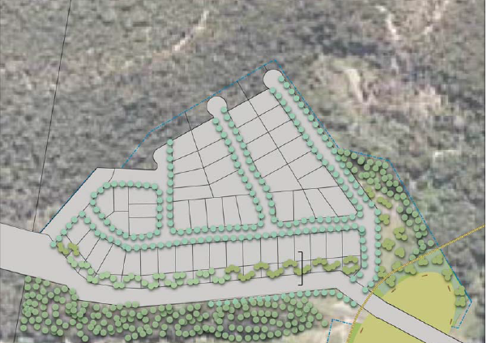

**Figure 8: Concept Plan Principles indicative lot layout incorporating vegetation buffer**

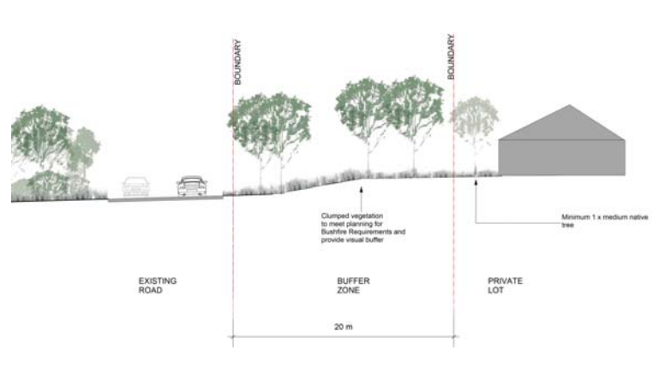

**Figure 9: Concept Plan Principles vegetation buffer section**

* 1. **Traffic impacts**

Condition 1.36 of the Concept Approval requires the intersection at Flowers Drive and Pacific Highway to be upgraded to address traffic impacts associated with the development.

The application was referred to TfNSW as traffic generating development under clause 2.112 and Schedule 3 of the Transport and Infrastructure SEPP 2021.

TfNSW are satisfied with the proposal and acknowledge upgrading of the intersection of Flowers Drive and the Pacific Highway, as required by the Concept Approval, will address potential traffic impacts arising from the development.

Consideration has also been given to the accessibility of the site, and potential traffic safety, road congestion and parking implications of the development. The development will provide suitable internal roads and safe intersections to Flowers Drive. Parking will be available within carriageways and on the lots with future housing.

The impact of construction traffic has been assessed with a construction management plan submitted with the application. The report identifies all haulage for the development to be via the northern end of Flowers Drive, aligning with community expectations. The report identifies the estimated peak traffic impact will be 30 trucks per day, occurring when the grouting works for Hamlet B (approximately 20 trucks per day importing grouting material) coincide with short periods (2-3 days) of high truck numbers required for the subdivision works occurring in Hamlet A (10 trucks per day when laying asphalt for roads or concrete for kerb and gutter and footpaths). The report identifies the grouting operation (importing of grouting material to mix on-site) is anticipated to occur for a period of up to 20 weeks.

The report identifies the lead in sewer and water infrastructure works within Flowers Drive will occur prior to the commencement of earthworks and grouting within Hamlet B. The upgrade works at the intersection of Flowers Drive and the Pacific Highway are expected to occur after the lead in sewer and water infrastructure works, prior to the completion of Hamlet A subdivision works.

The report identifies there is a balance between cut and fill shown on the preliminary civil plans and therefore no fill is proposed to be imported or exported to and from the site. Further, in accordance with RAP prepared for the site no contaminated soil is proposed to be removed from the site. Therefore, no additional construction traffic is expected to be generated from these activities.

* 1. **Ecological impacts – impacts on vegetation due to servicing and intersection works**

A water and sewer servicing strategy has been approved by HWC which provides both reticulated water and sewer services to the site. Servicing will be from Nords Wharf, across the Pacific Highway and along the road reserve of Flowers Drive.

Middle Camp Village is currently not serviced with reticulated water and sewer. As part of the development, a future connection point for the Middle Camp village will be provided.

The applicant has provided an alignment for the provision of water and sewer trenching, which is primarily already cleared or disturbed. An assessment of this alignment has been undertaken and there will not be a significant impact to vegetation.

Electrical power to the existing Middle Camp Village is via an existing cleared easement adjacent to Flowers Drive, and connects to the Pacific Highway. This easement is proposed to be utilised for the development.

The intersection works at the Pacific Highway will be contained within the existing area of pavement and as such will not require the clearing of any additional vegetation.

* 1. **Workshop Building**

Condition 1.32 of the Concept Approval requires a detailed heritage assessment of the workshop building and archaeological remains of the house to be prepared for any subdivision application for Hamlet B. The assessment is to investigate heritage significance, opportunities for adaptive re-use, recommendation for removal or retention, and ongoing management provisions (if retained).

A development application for demolition of the Workshop Building in Hamlet B has been assessed and approved by Council. The application did not include subdivision, and therefore sat outside of, and did not benefit from the Concept Approval.

* 1. **Workshop and Lemon Tree Parks**

Condition 1.8 of the Concept Approval requires if the Workshop and Lemon Tree parks are to be retained, then management arrangements for these parks are required.

The application previously proposed to remove Workshop and Lemon Tree Parks which would have triggered a requirement to modify the Concept Approval.

The application has been revised and proposes to maintain the Workshop and Lemon Tree parks.

Council has received draft terms of a positive covenant proposed by the applicant to ensure the parks are maintained by the developer, and to allow public access. Council considers the draft terms to be satisfactory at this stage.

A plan of management will be provided prior to the release of the Subdivision Certificate that creates these lots. The timing of this outcome forms part of the Staging Plan approved by DPIE.

* 1. **European heritage and heritage walkway**

The site contains six local heritage items all located within Hamlet B. The Concept Approval requires assessment and retention of heritage items within the development footprint.

The amended earthworks plans demonstrate all but one dwelling is not impacted by the proposed earthworks. This cottage (item CH-31) is proposed to be temporarily relocated and placed back on the site after earthworks are complete. The proposed filling at the location of CH-31 is required to achieve lots outside of the flood extent. A statement of heritage impact for relocating the cottage has been submitted, and is considered satisfactory by Council.

The Concept Approval and UDG provide for the construction of a heritage walkway. The application proposes construction of the heritage walkway from Hamlet B to the east over Middle Camp Creek and then to the south along the former rail corridor. Suitable preliminary civil design plans have been provided to assess the impact of the construction of this walkway.

An assessment of the heritage impact of the heritage walkway on the Catherine Hill Bay Colliery Railway has been submitted. Council’s Heritage Planner has reviewed and is satisfied with the documentation.

**5.11 Stormwater management**

Conditions 1.20 – 1.24 of the Concept Approval require the management of stormwater impacts from the development.

A suitable stormwater management plan has been submitted with the development application and includes gross pollutant traps and biofiltration basins to address the potential water quality impacts of the development, and capture and control discharge of stormwater to the watercourse in the southern portion of the site.

Stormwater modelling has been submitted to demonstrate the proposed stormwater management chain, including discharge to watercourse, will not have negative impacts on downstream properties in peak storm events.

A water quality and hydrological monitoring will be implemented to ensure the development does not adversely impact the adjacent wetland or Swamp Mahogany Paperbark Forest. The stormwater management report provides a suitable monitoring plan that will provide quarterly results to Council and NSW Office of Water from six months prior to the commencement of construction activities, until two years after the commissioning of the water quality facilities. National Park and Wildlife Services will also be provided a copy of the water quality monitoring results as requested by them through the consultation that has occurred in accordance with Condition 1.16f of the Concept Approval.

**5.12 Impacts to adjacent State Conservation Area**

The development is bounded by the Munmorah State Conservation Area along a majority of the perimeter (approx. 2.5 km of interface).

The interface with the conservation area will be delineated by public roads or Council reserves and landscaped with appropriate plantings. No private properties will interface with the conservation area. Retaining walls and associated earthworks required by the development that are adjacent to the conservation area will be offset a minimum of 3 metres from the property boundary to ensure minimal impact to the existing trees within the conservation area. An Arboricultural impact evaluation report has been provided to Council which identifies an offset of 2.5m to be sufficient to ensure the development will not impact the adjoining conservation area.

The application includes a Vegetation and Habitat Management Plan prepared in accordance with condition 1.16 of the Concept Approval. Section 8 of this report specifically addresses the interface with the conservation area, including access control, weed management and water quality monitoring measures.

Council has received correspondence from National Parks and Wildlife Services (NPWS) confirming they have reviewed the application and are satisfied with the management procedures of the interface lands.

1. **CONCLUSION & RECOMMENDATION**

It is recommended the application be approved pursuant to Section 4.16(1)(a) of the *Environmental Planning and Assessment Act 1979* subject to the draft conditions of consent attached to this report in Appendix A.